- Analysis and Comparison of the Curve-Fitted Equations for LOLC Holdings

We have two equations that model the stock price changes of LOLC Holdings before and after the COVID-19 pandemic. Let's break down and compare these equations in simple terms.
Pre-Pandemic Model
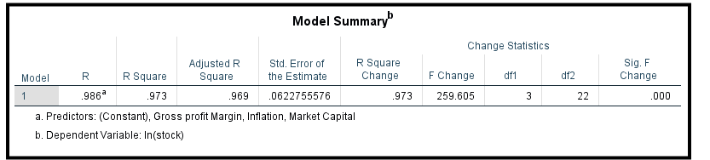
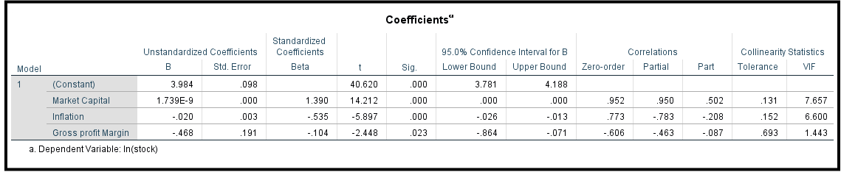

Stock Price = 3.984162 +1.7389E-9*Market Capital -0.019591*Inflation -0.467714*Gross profit Margin

Post-Pandemic Model
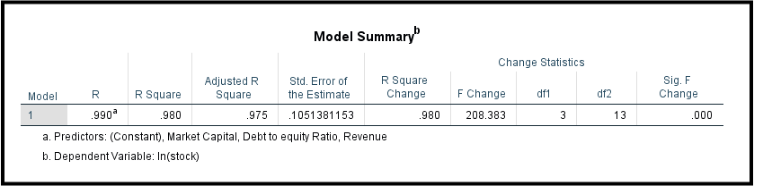
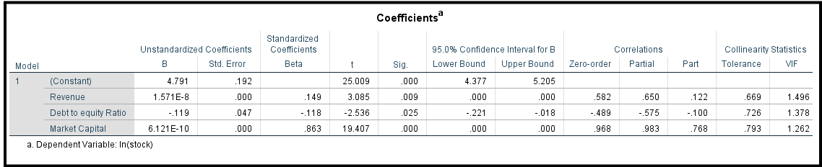

Stock Price = 4.791132 +1.5708E-8*Revenue -0.119470*Debt to equity Ratio +6.1207E-10*Market
Key Variables impacted in Pre-Pandemic Model
- Market Capital: 1.7389E-9 - A very small positive effect. As the company's market value increases, stock prices slightly go up.
- Inflation: (-0.019591) -A negative effect. Higher inflation leads to lower stock prices.
- Gross Profit Margin: (-0.467714) - A significant negative effect. If the company's profit margin decreases, the stock price drops.
Pre-COVID-19: Stock prices were more influenced by profitability metrics such as Gross Profit Margin and external economic factors like Inflation. This indicates that during stable economic periods, internal efficiency and broader economic conditions were key determinants of stock price performance.

Key Variables impacted in Post-Pandemic Model
- Revenue: A positive effect. Higher revenue means higher stock prices.
- Debt-to-Equity Ratio: A negative effect. More debt relative to equity leads to lower stock prices concerns about financial risk.
- Market Capital: Still a positive effect, though smaller than Revenue.

Post-COVID-19: The focus shifted towards Revenue and the Debt-to-Equity Ratio, suggesting that investors became more concerned with growth potential and financial stability post-COVID-19. Investors shifted their focus to how much money the company was making and its ability to manage debt. concerns about how companies would survive in a challenging economic environment. This change reflects the market's adaptation to a new economic environment where revenue generation and financial health became critical indicators of a company's value.

Market Capital: While it remained a factor across both periods, its impact became slightly more pronounced post-COVID-19, possibly reflecting the market's increased focus on company size and its ability to weather economic turbulence.

What Happened in March 2020?
•Small Drop in Stock Prices: When COVID-19 hit, there was global uncertainty, leading to a drop in stock prices. Investors were worried about the economic impact.
•Rapid Increase in Stock Prices After: The rise in stock prices afterward suggests that LLC Holdings showed strong revenue growth and managed its debt well, reassuring investors that the company could perform well even during tough times.

Using the Pre-COVID-19 Model for Post-COVID Predictions: The pre-COVID model might not predict post-COVID stock prices well because it doesn’t consider the new factors like revenue and debt that became important after the pandemic.

Residual Plot
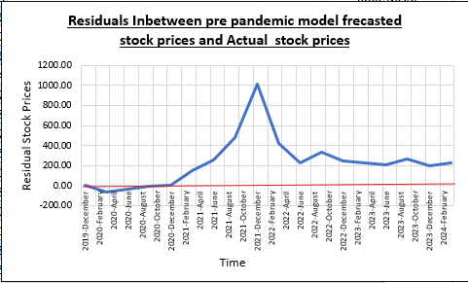
The residual plot shows significant deviations, particularly around the time when the pandemic hit.
The plot helps to emphasize the impact of the COVID-19 pandemic on stock prices. The sharp peak and subsequent drop in residuals underscore the magnitude of the market shock and its ongoing effects.
The sharp dip in residuals during late 2020 to early 2021 reflects the impact of the pandemic, which caused actual stock prices to rise sharply and unexpectedly. This period represents a "black swan" event—an unpredictable and rare event that significantly impacts financial markets. No pre-pandemic model could have reasonably predicted this because the pandemic caused fundamental changes in the economy, consumer behavior, and market dynamics.

Box plot
The main reason to analyze this box plot is to visually compare the distribution and variability of stock prices forecasted using a pre-pandemic model with the actual stock prices observed after the COVID-19 pandemic. This comparison allows for a quick and intuitive understanding of how well the pre-pandemic model predicts stock prices in the drastically changed post-pandemic environment.

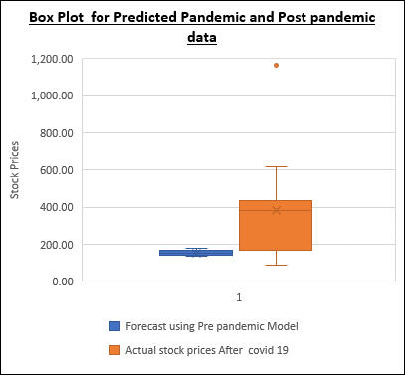
The blue box plot represents the forecasted stock prices using a pre-pandemic model, which shows a very tight distribution of predicted stock prices with minimal variability. This indicates a high confidence level in the model's predictions, supported by the high R-squared value of 0.97.
The orange box plot shows the actual stock prices after the COVID-19 pandemic, displaying a much wider range of variability, indicating significant changes and fluctuations in stock prices during the post-pandemic period.
Forecast using Pre pandemic Model |  | Actual stock prices After covid 19
Mean | 154.4645548 | Mean | 384.4889
Standard Error | 3.144037253 | Standard Error | 58.72974
Median | 153.0263159 | Median | 383.625
Mode | #N/A | Mode | #N/A
Standard Deviation | 13.33902037 | Standard Deviation | 249.1692
Sample Variance | 177.9294645 | Sample Variance | 62085.28
Kurtosis | -0.868908239 | Kurtosis | 4.931476
Skewness | 0.18311045 | Skewness | 1.751304
Range | 44.35116005 | Range | 1071.2
Minimum | 134.3832939 | Minimum | 90.8
Maximum | 178.734454 | Maximum | 1162
Sum | 2780.361986 | Sum | 6920.8
Count | 18 | Count | 18
Confidence Level(95.0%) | 6.633338775 | Confidence Level(95.0%) | 123.9089

- Mean and Median Values:
- The mean of the forecasted stock prices using the pre-pandemic model is approximately 154.46 and the median is 153.03 which aligns closely with the mean, indicating a relatively symmetric distribution in the forecast.
- The mean of the actual stock prices after COVID-19 is much higher at 384.49 and the median is 383.63, also close to its mean, showing that the distribution is centered around much higher values compared to the forecast.

- Standard Deviation and Variance:
- The standard deviation of the forecasted prices is 13.34, with a variance of 177.93, indicating low variability and high confidence in predictions.
- For the actual prices, the standard deviation is much higher at 249.17, with a variance of 62,085.28, showing that actual stock prices have experienced significant fluctuations post-pandemic.
The data clearly show that the COVID-19 pandemic has had a profound impact on the stock prices of LOLC Holdings
The pre-pandemic model, despite being accurate for its time, is unable to account for the large increases and volatility observed in the actual post-pandemic prices. This suggests that the pandemic introduced new factors affecting stock prices that were not present or relevant before, such as shifts in market dynamics, investor sentiment, or economic policies. The pandemic has caused a structural change, leading to higher stock prices and greater uncertainty, which the pre-pandemic model could not predict.

Scatter Plot

The primary purpose of analyzing this scatter plot is to evaluate the relationship between stock prices predicted by a pre-pandemic model and the actual stock prices observed after the COVID-19 pandemic. This analysis helps to visually assess how well the pre-pandemic model's predictions align with the real-world data during a period of significant market disruption.
- The scatter plot shows a weak relationship between the pre-pandemic model’s forecasts (X-axis) and the actual stock prices after COVID-19 (Y-axis). The points are widely scattered with very little correlation.
- The R-squared value of 0.0157 indicates that the pre-pandemic model explains only about 1.57% of the variance in the actual post-pandemic stock prices. This means the model has very limited predictive power in the post-pandemic period.

The weak correlation indicates that the market dynamics have changed significantly due to COVID-19, rendering the model obsolete for the new economic environment.

Revenue growth
The plantation sector has been a significant contributor to the revenue growth of LOLC Holdings, particularly during the financial year 2020/21. During this period, Browns Agri Solutions, a key player in the crop protection market, achieved a remarkable year-on-year turnover growth of 76% and profit growth of 119%. Similarly, Maturata Plantations saw a 19% increase in tea production and a 35% rise in tea turnover, driven by improved agricultural practices and favorable market conditions. The rubber segment also turned around from losses, achieving a 43% increase in production and generating a gross profit after years of underperformance. Additionally, cinnamon, as part of the company’s diversification strategy, recorded a substantial 93% increase in turnover. These achievements highlight how the plantation sector has played a pivotal role in driving LOLC Holdings’ revenue growth, with significant impacts on the company’s overall profitability and stock market performance during the 2020/21 financial year.

Conclusion
COVID-19 had a profound impact on the stock market of LOLC Holdings, fundamentally changing the factors that influence stock prices. Before the pandemic, the company's stock prices were more influenced by internal profitability metrics like gross profit margin and external economic factors like inflation. However, after the pandemic, the focus shifted toward revenue growth and financial stability, as measured by the debt-to-equity ratio. The pandemic introduced new economic uncertainties, causing significant fluctuations in stock prices that the pre-pandemic models could not predict. The models used before COVID-19 became outdated, as they failed to account for the new market dynamics, leading to higher and more volatile stock prices post-pandemic.

